# [Earthquake Detector Alarm using Arduino](https://circuitdigest.com/microcontroller-projects/arduino-earthquake-detector-alarm-circuit)

By [Saddam](https://circuitdigest.com/users/saddam) [3 Comments](https://circuitdigest.com/microcontroller-projects/arduino-earthquake-detector-alarm-circuit/#comments)

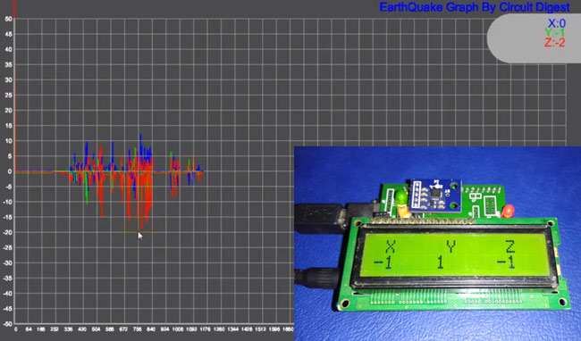*Earthquake Detector Arduino Shield using Accelerometer*

An earthquake is an unpredictable natural disaster that causes damage to lives and property. It happens suddenly and we cannot stop it but we can be alerted from it. In today’s time, there are many technologies which can be used to detect the small shakes and knocks, so that we can take precautions prior to some major vibrations in earth. Here we are using [Accelerometer ADXL335](https://circuitdigest.com/tags/accelerometer) to detect the pre-earthquake vibrations. Accelerometer ADXL335 is highly sensitive to shakes and vibrations along with all the three axes. Here we are building an **Arduino based Earthquake Detector using Accelerometer**.

We are here building this **Earthquake detector as a Arduino Shield on PCB**and will also show the Vibrations Graph on computer using [Processing](https://processing.org/" \t "_blank).

### Components Required:

* Arduino UNO
* Accelerometer ADXL335
* 16x2 LCD
* Buzzer
* BC547 transistor
* 1k Resistors
* 10K POT
* LED
* Power Supply 9v/12v
* Berg sticks male/female

**Accelerometer:**

Pin Description of accelerometer:

1. Vcc         5 volt supply should connect at this pin.
2. X-OUT   This pin gives an Analog output in x direction
3. Y-OUT   This pin give an Analog Output in y direction
4. Z-OUT   This pin gives an Analog Output in z direction
5. GND      Ground
6. ST          This pin used for set sensitivity of sensor

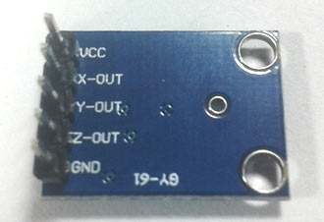 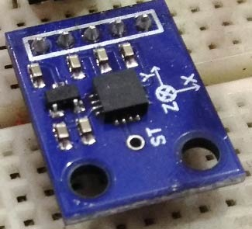

Also check our other projects using Accelerometer:

* [Ping Pong Game using Arduino](https://circuitdigest.com/microcontroller-projects/ping-pong-game-using-arduino-accelerometer)
* [Accelerometer Based Hand Gesture Controlled Robot.](https://circuitdigest.com/microcontroller-projects/accelerometer-based-hand-gesture-controlled-robot-using-arduino)
* [Arduino Based Vehicle Accident Alert System using GPS, GSM and Accelerometer](https://circuitdigest.com/microcontroller-projects/arduino-based-accident-alert-system-using-gps-gsm-accelerometer)

### Working Explanation:

Working of this **Earthquake Detector** is simple. As we mentioned earlier that we have used Accelerometer for detecting earthquake vibrations along any of the three axes so that whenever vibrations occur accelerometer senses that vibrations and convert them into equivalent ADC value. Then these ADC values are read by Arduino and shown over the 16x2 LCD. We have also shown these values on **Graph using Processing**. Learn more about Accelerometer by going through our other [Accelerometer projects here](https://circuitdigest.com/tags/accelerometer).

First we need to **calibrate the Accelerometer** by taking the samples of surrounding vibrations whenever Arduino Powers up. Then we need to subtract those sample values from the actual readings to get the real readings. This calibration is needed so that it will not show alerts with respect to its normal surrounding vibrations. After finding real readings, Arduino compares these values with predefined max and min values. If Arduino finds any changes values are more then or less then the predefined values of any axis in both direction (negative and positive) then Arduino trigger the buzzer and shows the status of alert over the 16x2 LCD and a LED also turned on as well. We can adjust the sensitivity of Earthquake detector by changing the Predefined values in Arduino code.

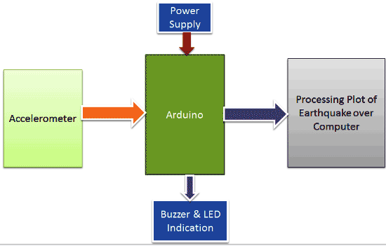

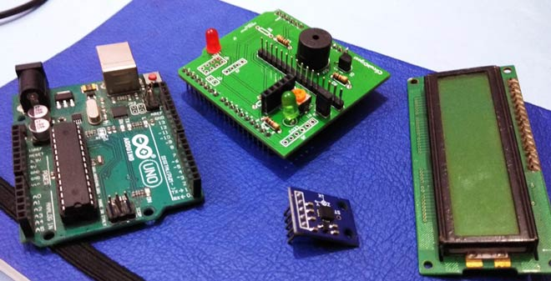

**Demonstration Video and Arduino Code** are given at the end of the article.

### Circuit Explanation:

Circuit of this **Earthquake detector Arduino Shield PCB** is also simple. In this project, we have used Arduino that reads accelerometer’s analog voltage and convert them into the digital values. Arduino also drives the buzzer, LED, [16x2 LCD](https://circuitdigest.com/article/16x2-lcd-display-module-pinout-datasheet) and calculate and compare values and take appropriate action. Next part is Accelerometer which detects vibration of earth and generates analog voltages in 3 axes (X, Y, and Z). LCD is used for showing X, Y and Z axis’s change in values and also showing alert message over it. This LCD is attached to Arduino in 4-bit mode. RS, GND, and EN pins are directly connected to 9, GND and 8 pins of Arduino and rest of 4 data pins of LCD namely D4, D5, D6 and D7 are directly connected to digital pin 7, 6, 5 and 4 of Arduino. The buzzer is connected to pin 12 of Arduino through an NPN BC547 transistor. A 10k pot is also used for controlling the brightness of the LCD.

[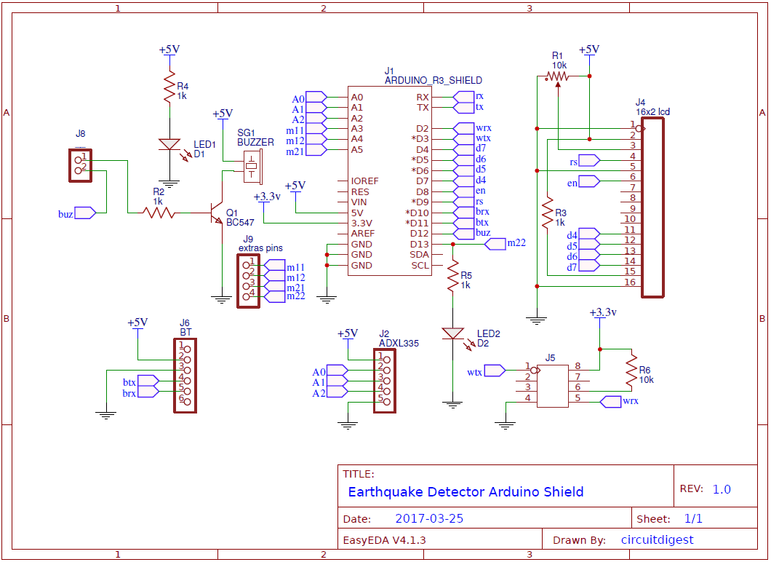](https://circuitdigest.com/fullimage?i=circuitdiagram_mic/Earthquake-indicator-arduino-shield-using-accelerometer-circuit-diagram.gif)